Design and Construction Requirements for Exit Routes Training Material and
Comprehension Quiz

- Policy
  - Romero’s Food Products Inc. ensures exit routes comply with the requirements for an exit route and exit discharge that is essential for the safety of employees when an emergency event arises.

- Procedure
  - Design and construction requirements for exit routes
    - Basic requirements
      - Ensures that the exit route provided in the workplace is permanent.
      - Ensures that the exit route connecting three or fewer stories is made from one-hour fire resistance-rating materials. The exit route connecting four or more stories is made from two-hour fire resistance-rating materials.
      - Requirements for openings in an exit
        - Ensures that an opening into an exit is only permitted to allow access to the exit from the occupied area of the workplace.
        - Provides openings that are protected by a self-closing fire door that remains closed or automatically closes in an emergency upon the sounding system like a fire alarm or employee alarm.
        - Use a fire door, including the frame and hardware that is listed or approved by a nationally recognized testing laboratory.
    - Number of adequate exit routes
      - A single exit route is provided to the workplace such that all employees would be able to evacuate safely during an emergency.
      - Two exit routes are provided to permit prompt evacuation of employees and other building occupants during an emergency. These routes are constructed as far away from each other so that once one route is blocked by fire or smoke, the other route will be used for evacuation.
      - More than two routes are provided based on the total number of employees, the size of the building, or the workplace arrangement to ensure that all employees will be safely evacuated during an emergency.
    - Exit discharge
      - Ensures each provided exit discharge directly leads outside the workplace, a street, a walkway, a refuge area, a public way, or any open space outside the workplace.
      - The street, walkway, refuge area, public way, or open space provided is large enough to accommodate all the evacuees during an evacuation.
      - Provides exit stairs with the direction of travel that leads to the exit discharge.
    - Exit door
      - Ensures the exit door from the inside can be readily opened without the use of any keys, tools, or special knowledge. A panic bar that locks only from the outside is permitted on exit discharge doors.
      - Make sure the exit door is free of any device or alarm that will restrict emergency use once the device or alarm fails.
      - An exit route that locks on the inside is only permitted in mental, penal, or correctional facilities where supervisory personnel on duty have the authority to remove occupants from the facility during an emergency.
    - Side-hinged exit door
      - Provides a side-hinged exit door connected to an exit route.
      - Make sure the side-hinged exit door swings out in the direction of exit travel in rooms designed to be occupied by more than 50 people or in rooms categorized as high-hazard areas.
    - Capacity of exit route
      - Ensures exit route supports the maximum number of occupants permitted for each floor.
      - Conforms the capacity of the permitted occupant of the exit route going to the exit discharge is constant.
    - Exit route minimum height and width requirements
      - The ceiling for the exit route is at least seven feet six inches (2.3 m) high. Projection from the ceiling measures not less than six feet eight inches (2.0 m) from the floor.
      - Ensures exit access is at least 28 inches (71.1 cm) wide at all points. Exit access for a single exit route is equal to the exit and exit discharge width.
      - Ensures the width of the exit route is sufficient to accommodate the maximum load of a permitted occupant for each floor.
      - Ensures the minimum required width of the exit route is not reduced by any projected objects in the exit route.
    - Outdoor exit route
      - Provides an outdoor exit route with guardrails that protect unenclosed sides from fall hazards.
      - Provides cover from snow or ice accumulation along the route.
      - Ensures that the outdoor exit route is reasonably straight and has smooth, solid, and substantially level walkways.
      - Ensures that the outdoor exit route is not a dead-end longer than 20 feet (6.2 m).
  - Illustrations
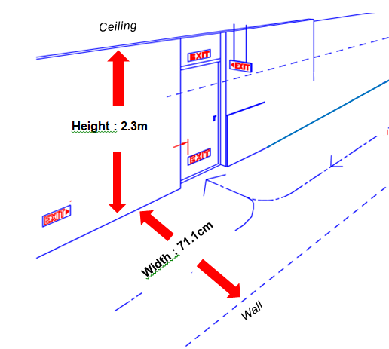
    - Illustration for required minimum height and width for an exit route

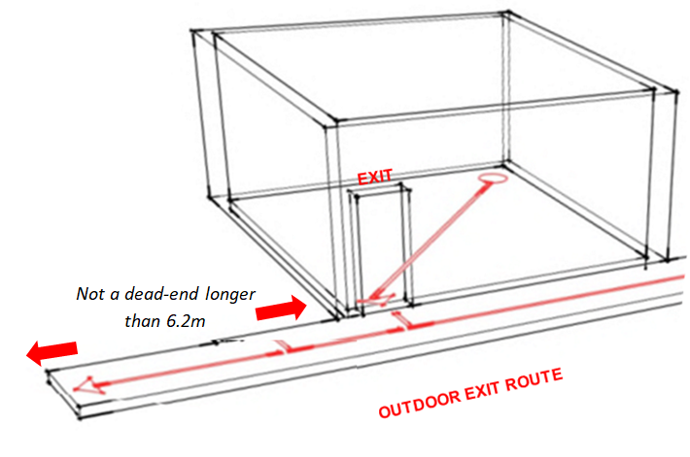

2.2.2 Illustration for an outdoor exit route

- Responsibility
  - Management
    - Ensures exit routes are provided at the workplace.
    - Provides adequate exit routes based on the number of employees and the size of the building.
    - Ensures that existing doors for exit routes are made from fire-resistant materials.
    - Provides maintenance and routine inspections for all exit doors and sounding systems.
    - Make sure employees are properly trained on the location of the exit routes for any emergency.
    - Ensures that the exit route complies with the minimum required width.
  - Supervisors
    - Ensure employees follow the designated exit route when an emergency arises.
  - Employee
    - Make use of the exit route following the maximum load capacity when an emergency arises.

- Corrective Action
  - Unsafe conditions such as exit route width are not within the permitted width and violations of safe operating practices are immediately reported to supervisors.

- Review – Quality
  - Review the revised needs of the required exit routes and exit discharge, if any.
  - Routinely check the compliance of the policy from the employees.
  - Updates on the revised design and construction requirements for exit routes.

- History
Revision No.: | Revision Date: | Description of Change: | Originator / Author Name: | Title / Department:
0 | 20220830 | Original | Arnel Ryan | PCQI/Compliance
1 | 20240115 | - Aligned with the updated program.  - Updated the Procedure and Review Quality.  - Updated Comprehensive Quiz.  - Added Comprehension Quiz: ANSWER KEY. | Arnel Ryan | PCQI/Compliance
2 | 20241122 | - Changed title part from Comprehensive to Comprehension  - Changed email from rfp@interlinkiq.com to rfp@consultareinc.com  - Added training material title to Comprehension Quiz section | Arnel Ryan | PCQI/Compliance

Requirements:
- The trainee has read or received a verbal translation of all or part of the policy, procedure, method, and or SOP for which they are being trained.
- The trainee has observed a demonstration of the task they are to perform or the procedure for which they are being trained as required.
- The trainee has demonstrated the ability to perform the task with acceptable proficiency and with minimal supervision as required.

TRAINEE (Print Name): | TRAINEE (Signature): | Date: | Department:
Trainer / Supervisor (Print Name): | Trainer (Signature): | Date: | Department:

UPON COMPLETION – EMAIL TO rfp@consultareinc.com

NAME (Print): | Date:

Design and Construction Requirements for Exit Routes Comprehension Quiz

Direction: Choose the best answer and encircle the letter.

- This door swings out in the direction of exit travel in rooms.
- Exit discharge
- Exit door
- Side-Hinged Exit Door

- Who is responsible for providing maintenance and routine inspections for all exit doors?
- HR Department
- Management
- Administrative Department

- The ceiling for the exit route is at least seven feet six inches (2.3 m) high.
- True
- False

- The exit route connecting four or more stories is made from four-hour fire resistance-rating materials.
- True
- False

- The outdoor exit route is not a dead-end longer than _______.
- 19 feet (5.8 m)
- 20 feet (6.2 m)
- 21 feet (6.4 m)

UPON COMPLETION – EMAIL TO rfp@consultareinc.com

